Setting up an event on Eventbrite

- Open up Eventbrite and click ‘Create an event’

- Complete the basic info page – select the appropriate CIBSE Group/Society/Region to be the event organiser from the drop down menu and choose ‘Seminar or Talk’ and ‘Science and Technology’ for the Type and Category options

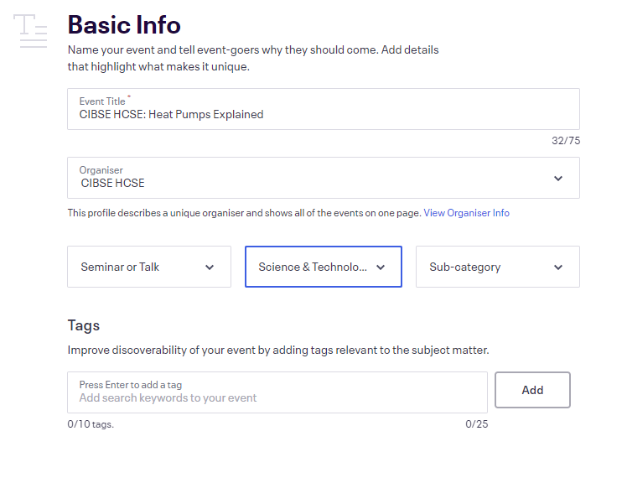
- Choose ‘Online event’ for location if it is for a webinar
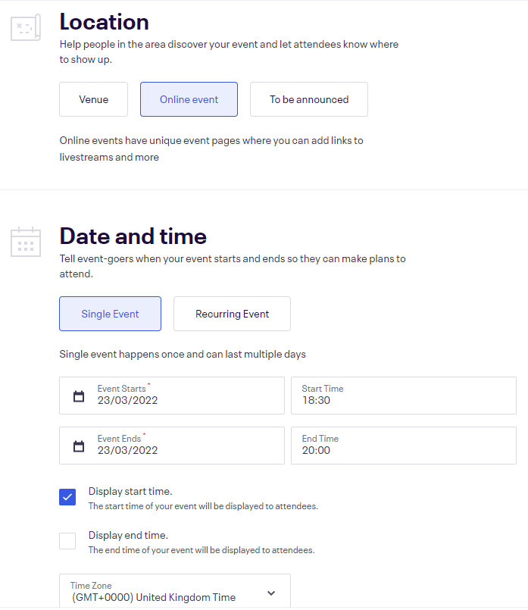

- For the details section, choose an appropriate image to illustrate the event (ensure it is royalty free or purchase one from Shutterstock)
- Repeat the title in the summary section, and write a description for the event in the text box
- Use the ‘Add text’ and ‘Add image’ buttons to add the Group/Region/Society’s logo, any sponsor logos, and the CIBSE Privacy Policy to the page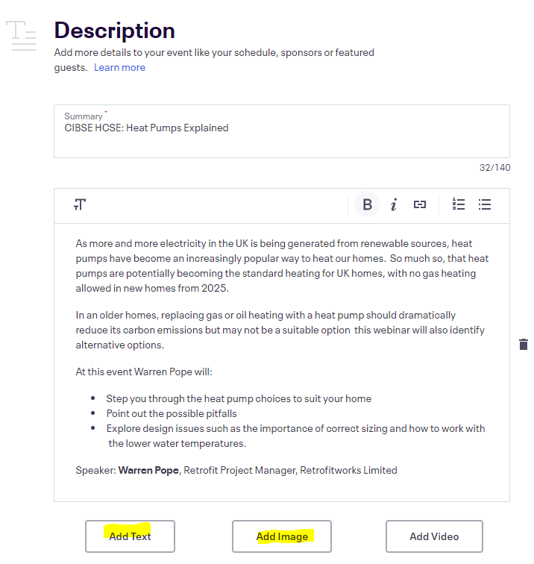

- Create the attendee event page – choose ‘link another provider’ and insert the joining link
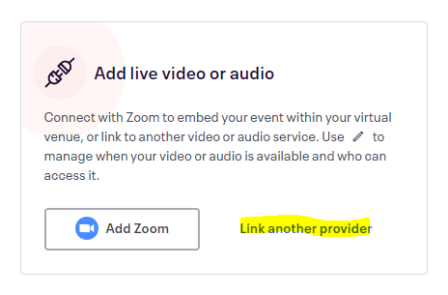
- Create the tickets
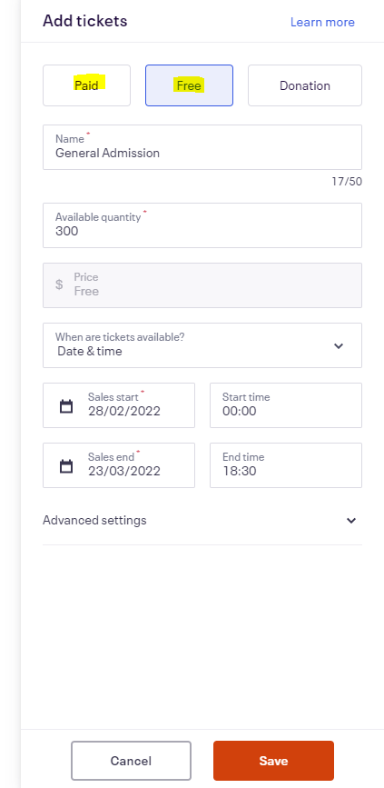

- Review the details of the completed event page and click publish

