Running a Group/Society/Region seminar on Microsoft Teams Meetings

Creating your joining link:
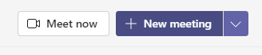
In the Microsoft Teams app:
- Click on the ‘New Meeting’ icon in the top right-hand corner
- Complete the required fields, and add your presenters to the attendee fields
- Don’t forget to set the time to 15 minutes prior to the event start time, to allow time to check your presenters’ microphones and cameras are working
In Outlook:
- Open your calendar and send a diary invite to your presenters, remembering to turn on the ‘Teams meeting’ feature
- Don’t forget to set the time to 15 minutes prior to the event start time, to allow time to check your presenters’ microphones and cameras are working
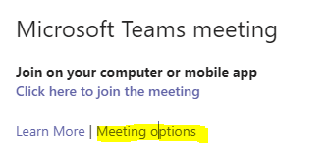
Issue these links to your delegates via the ‘Online event page’ or ‘Messages to attendees’ features on Eventbrite
Next, set up the meeting options (this is found once you have generated your booking link in the meeting invite.
You can choose the settings to suit you, but we recommend the following:
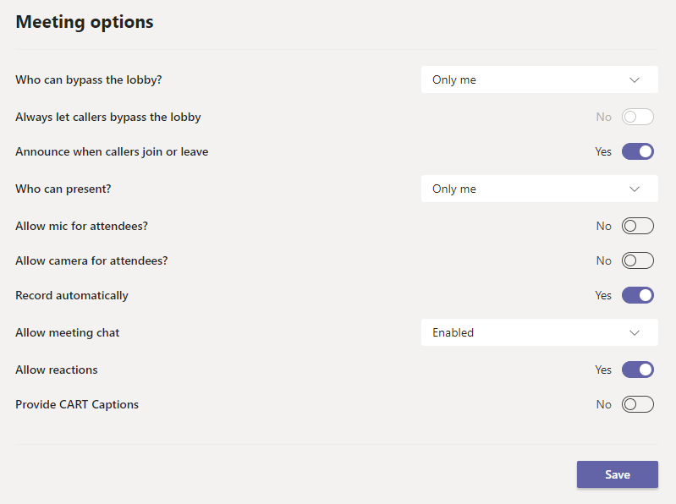
Who can bypass the lobby? You will need to admit the speakers to the meeting so that they can bypass the lobby, but setting this to ‘Only me’ will allow you to talk to them privately before the webinar. When you are ready, you can click ‘admit all’ to admit the delegates. You will need to continue admitting any latecomers unless you change this to ‘everyone’ during the meeting (click on the three dots at the top of the screen and select ‘meeting options’).
Who can present? Again, you will need to click on the dots by a presenter’s name and select ‘make a presenter’ when they arrive in the meeting, but this stops attendees being allowed to share their screens and microphones during the session. Presenters will need to un-mute themselves at the beginning of the meeting.
Allow mic/camera for attendees? Set to no to stop the audience being able to interrupt the meeting. If you want to allow attendees to turn on their microphones for the Q&A, you can change this setting during the meeting by clicking on the three dots at the top of the screen and selecting ‘meeting options’.

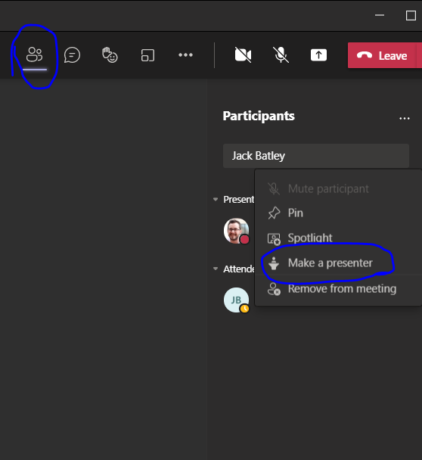
Starting your event:
- Join the meeting link you have created
- Go to the list of participants. Set your speakers and organisers to presenters as they start arriving on the call
- Ignore any pop ups that announce delegates arriving – they will be left in the lobby until you are ready to admit them (don’t click dismiss!)
- When you are ready to start the webinar, click ‘Admit all’ to allow your delegates to enter. If you haven’t set the meeting to record automatically, don’t forget to start the recording (find this option by clicking on the three dots at the top of the screen).
- When you are ready to finish the event, click on the drop down menu for the red ‘leave’ button and click ‘end for all’.

