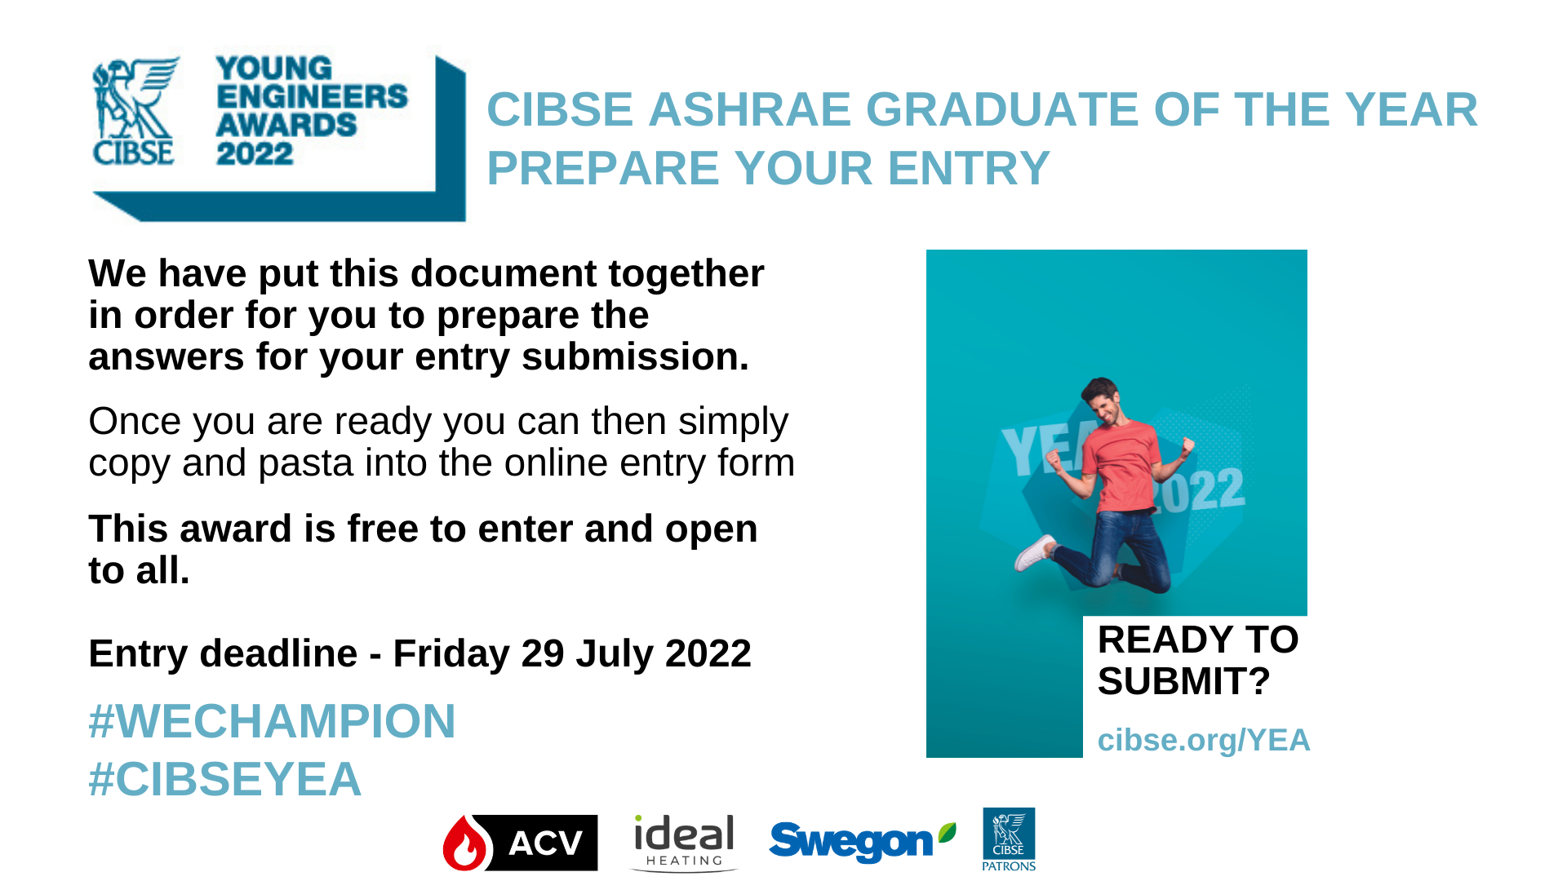

CIBSE ASHRAE Graduate of the Year entry questions

The below information for both the Nominator and Graduate will need to be provided:

- First Name
- Last Name
- University / College / Company: (as it should appear in a press or publicity release)
- Position/Job title
- Email address
- Phone number

The following questions must be answered by the nominator to complete the entry

What has the candidate achieved academically and/or in practical projects?
(250 words max)
Click or tap here to enter text.

Why would the nominee be a good ambassador building services profession?
(250 words max)
Click or tap here to enter text.

Please note
You will be able to additionally submit a single PDF document that you think could substantiate your entry – but please note that the information on the form will be the principal source of information used for shortlisting candidates.

